MAIN PROJECT-1

Deploying a Highly Available Web Application and Bastion Host Using NAT gateways in AWS

Steps:

1. Selecting a N.Virgina region and perfoeming all the task in the same region.
2. Creating a VPC with IPv4 CIDR as 10.0.0.0/16.

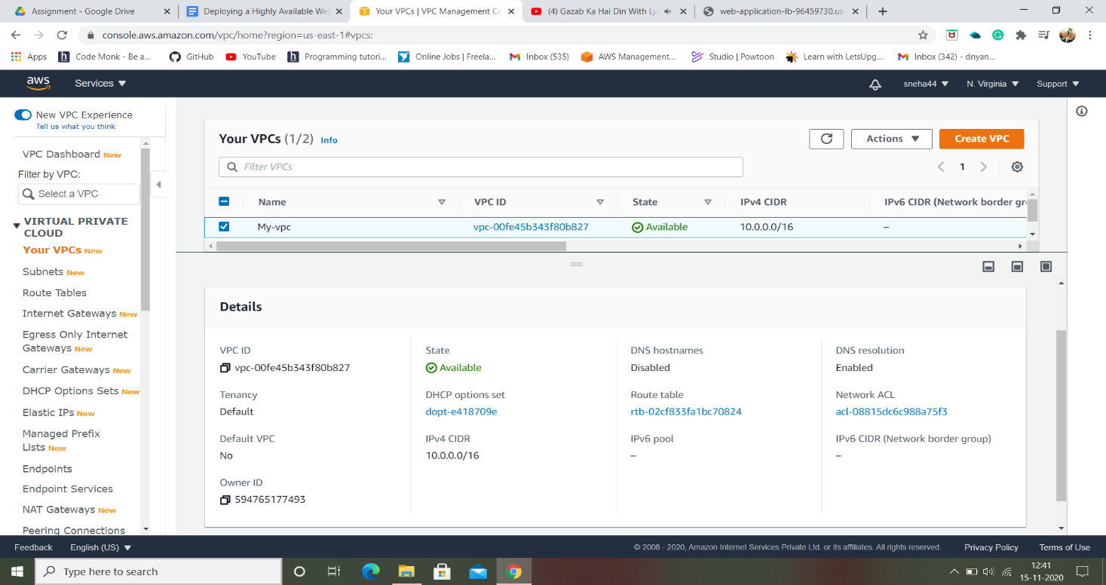

1. Creating a subnet called Public-Subnet with the vpc we created and enabling Auto-assign IPv4:

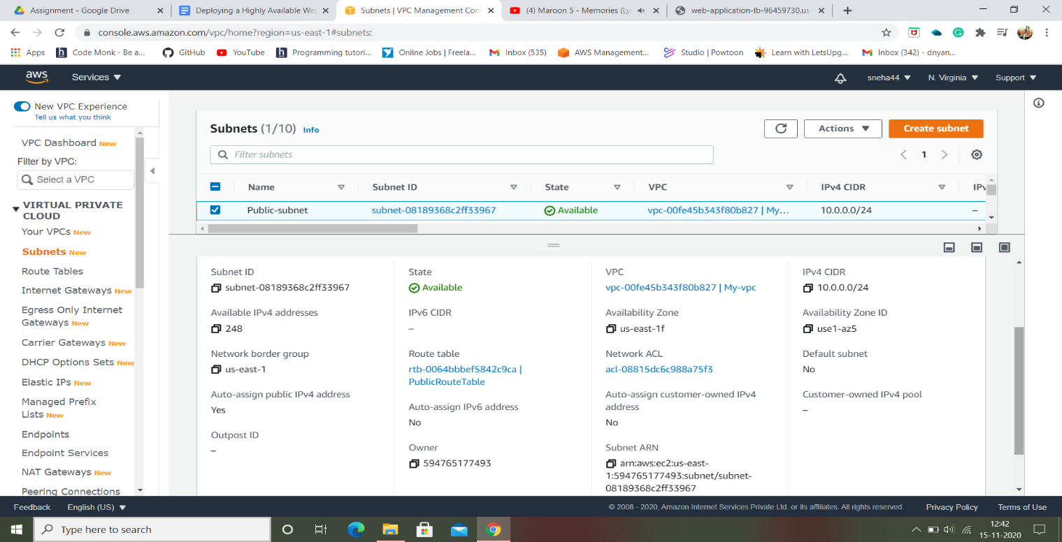

Now the Instances launched inside the *Public-Subnet*will have Public IPs assigned to them by default.

1. Creating a Private-Subnet with IPv4 CIDR as 10.0.1.0/24 for the private web-server.

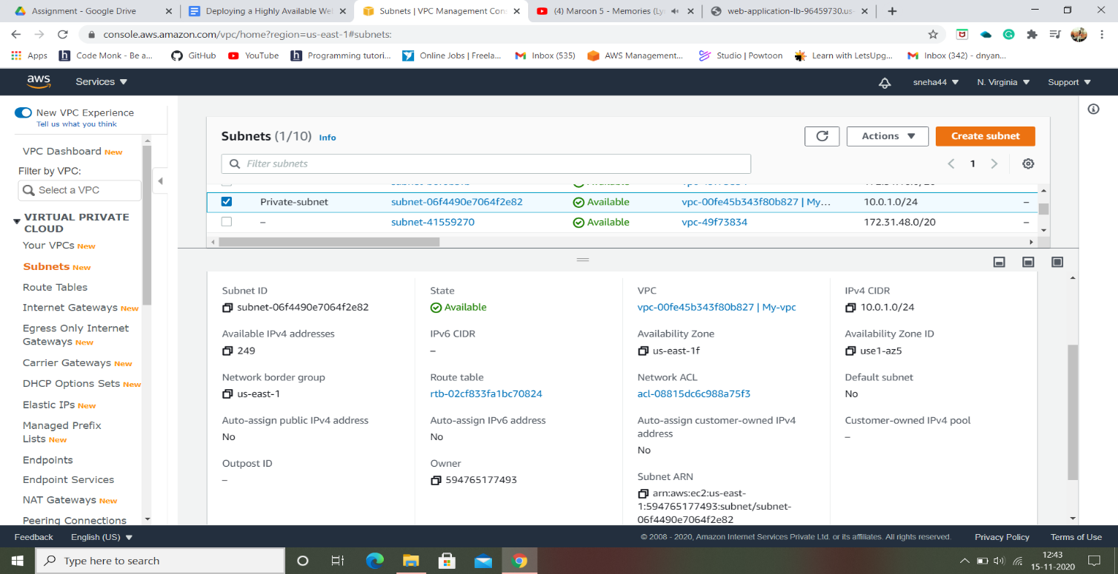

1. Creating two more subnets with different availablity zones by IP’s such as 10.0.2.0/24 and 10.0.4.0/24:

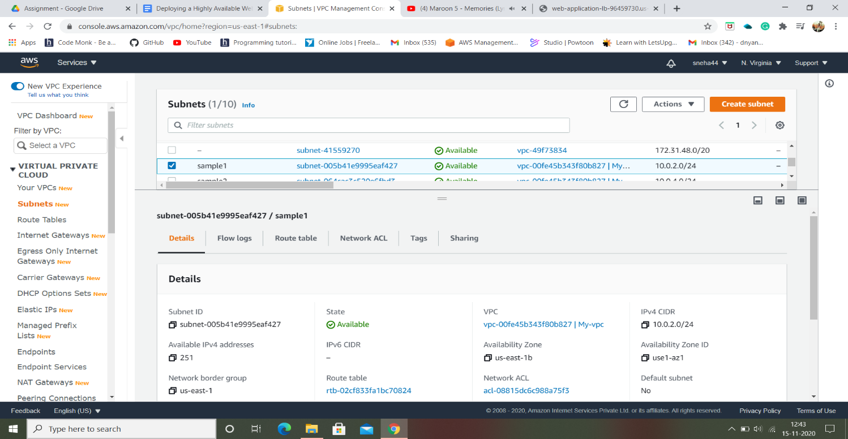

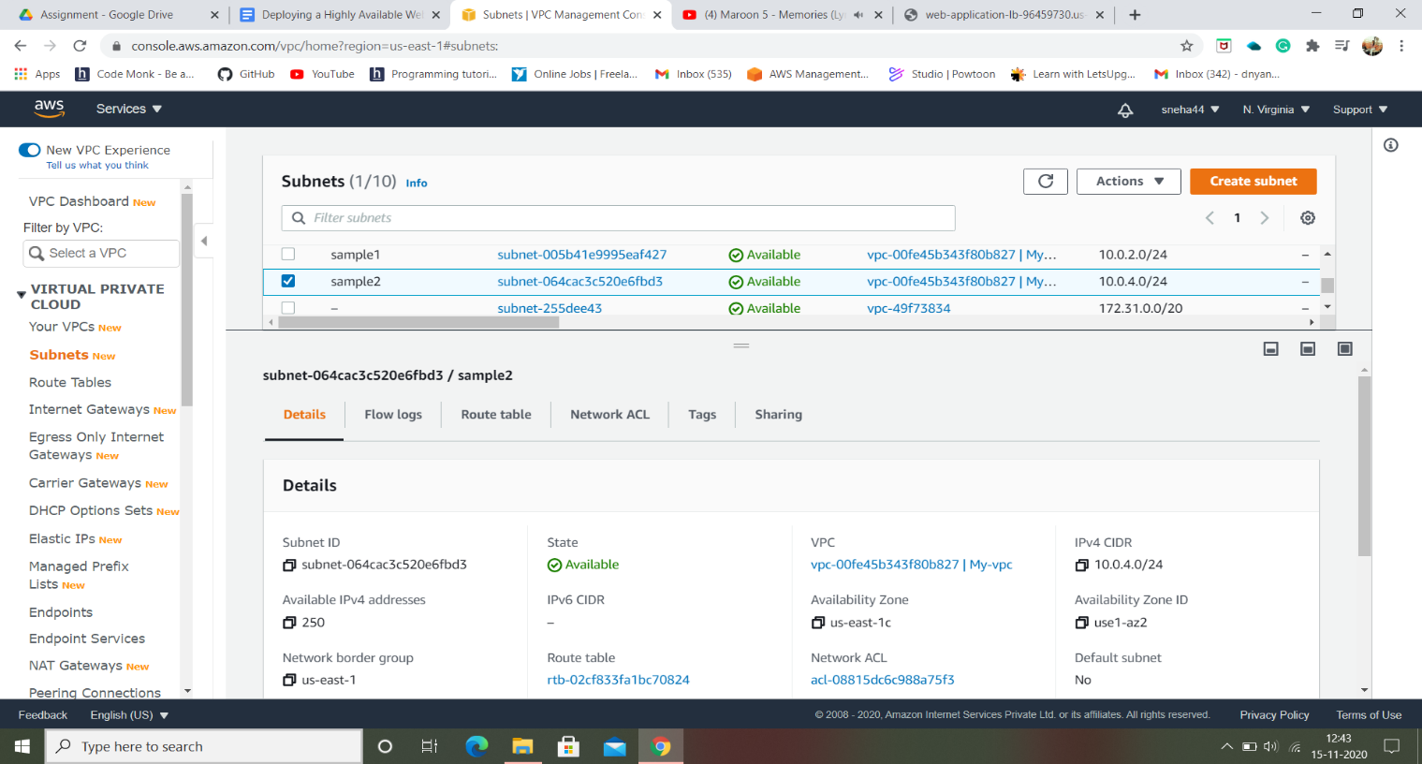

1. Creating a Internet gateway and attach to the vpc we created as My-vpc:

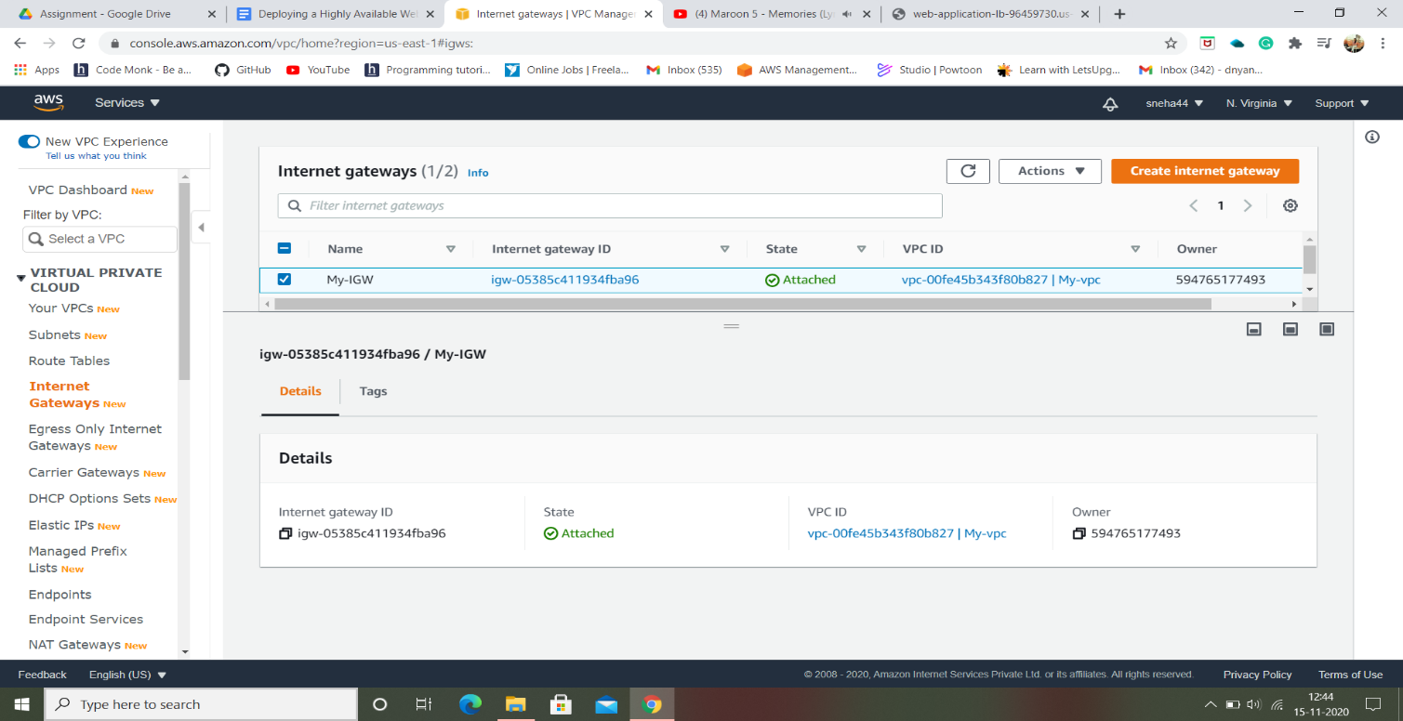

1. Creating a route table for public subnet and editing routes by adding a new route of Internet gateway with IP address as 0.0.0.0/0:

Here, the route table is not made as a main domain. As a default route table is created attached by the VPC we created as “My-vpc”.  It is a main route table created at the time the VPC was created. We will use it while creating the **NAT Gateway**.

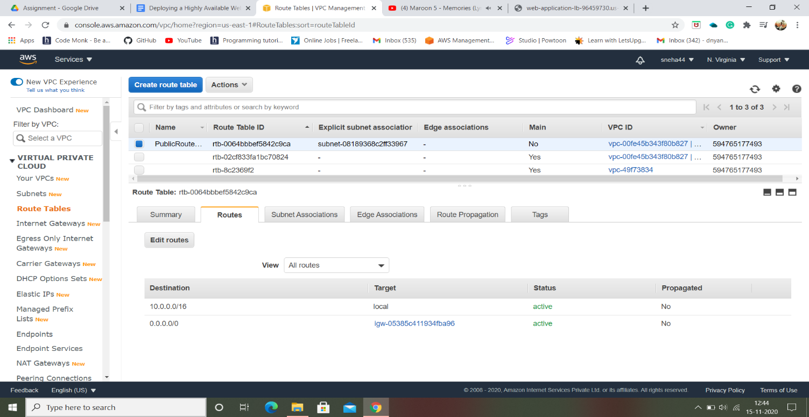

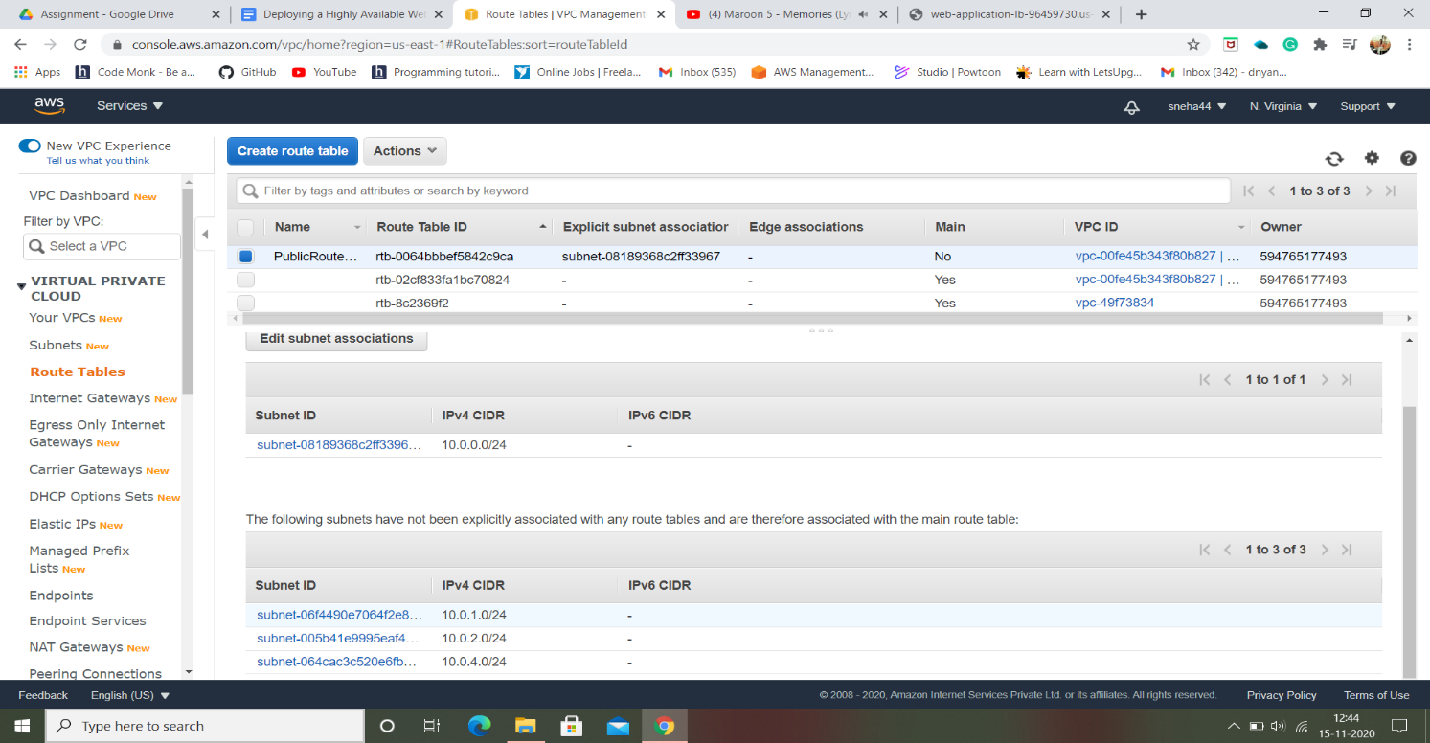

1. Creating a NAT gateway with Public-Subnet:

When we launch instances further no internet access is provided for EC2 instances in a private subnet, so we will not be able to get updates. To avoid such situation we need to create a NAT gateway which will provide the internet access to the instances inside the private subnet. After creating we will update the default route table which wasn’t created by us.

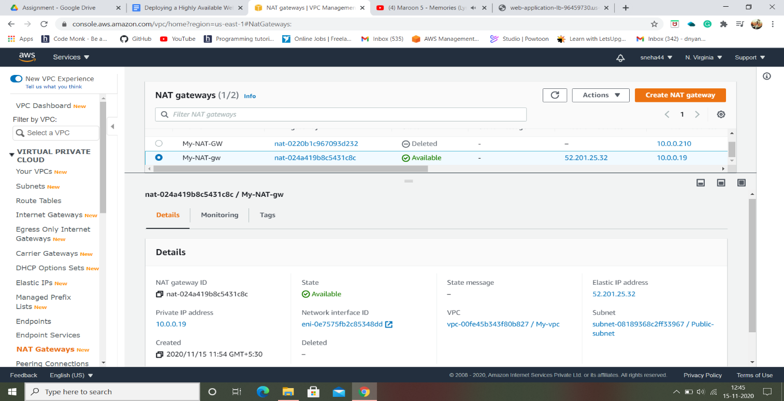

1. Launching a Bastion host server:

**A bastion host is a system**that is exposed to the internet. In terms of security, Bastion is the only server that is exposed to the internet and should be highly protective to malicious attacks. The Bastion server filters the incoming traffic and prevents unwanted connections entering the network thus acting as a gateway to maintain the security of bastion hosts, all unnecessary software, daemons.

* Creating a Bastion host server by selecting A**mazon Linux 2 AMI (HVM), SSD Volume Type.**
* The VPC we created and a public subnet.
* Also, the new security group named “Bastion-SG”.

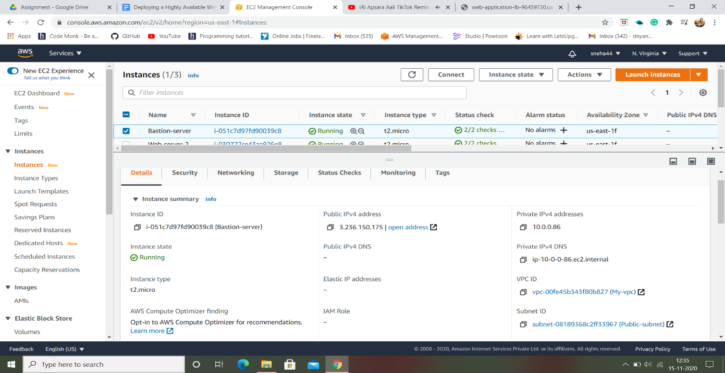

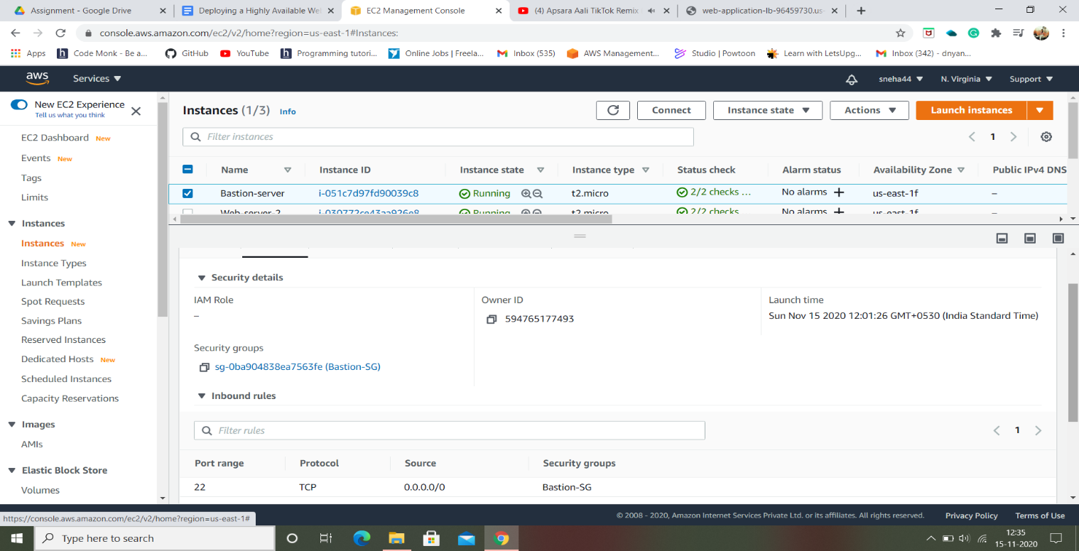

* Security group for Bastion host server using SSH type:

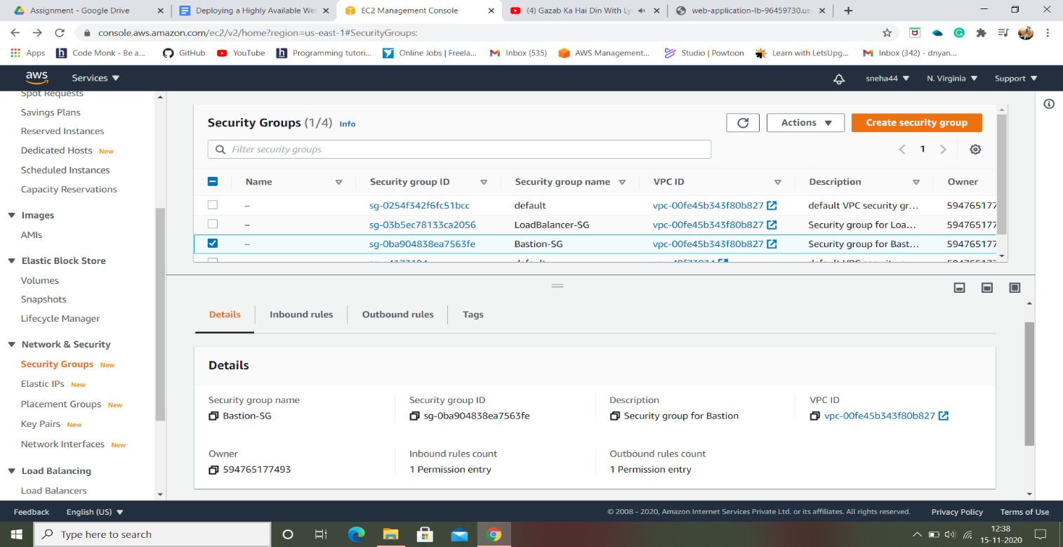

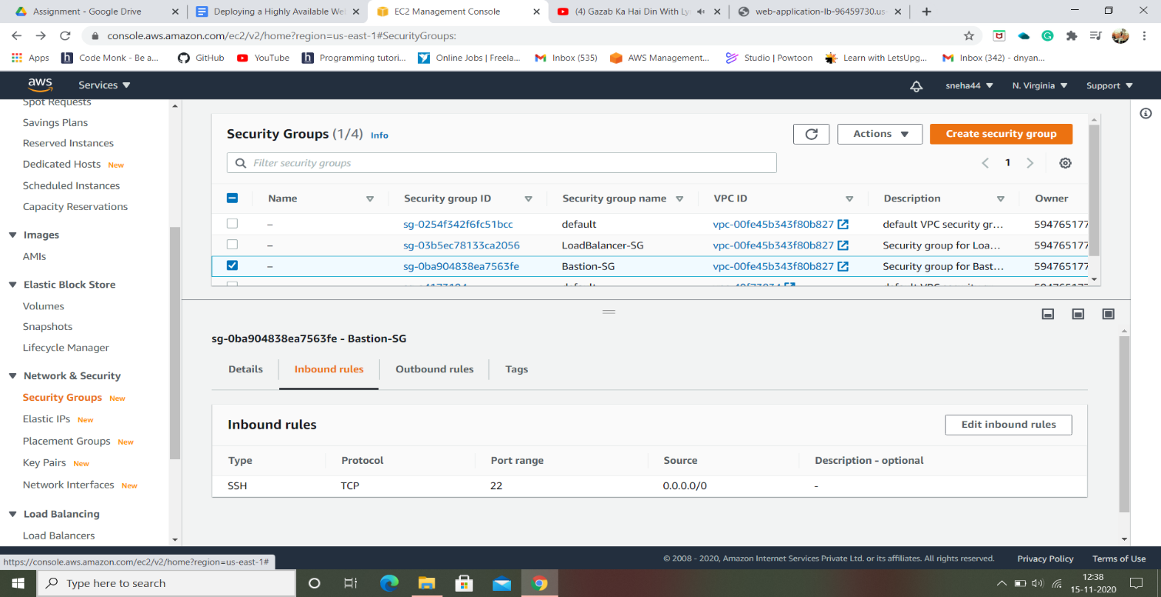

1. Creating a Security Group for Load Balancer using HTTP type:

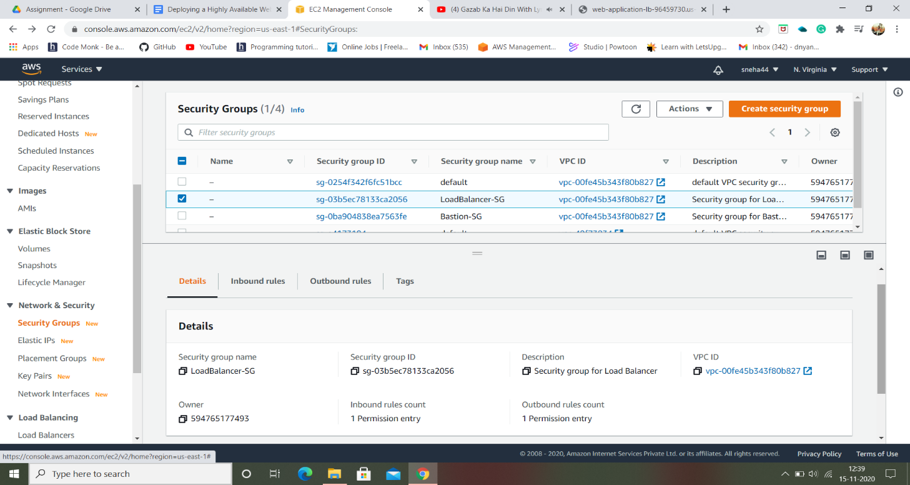

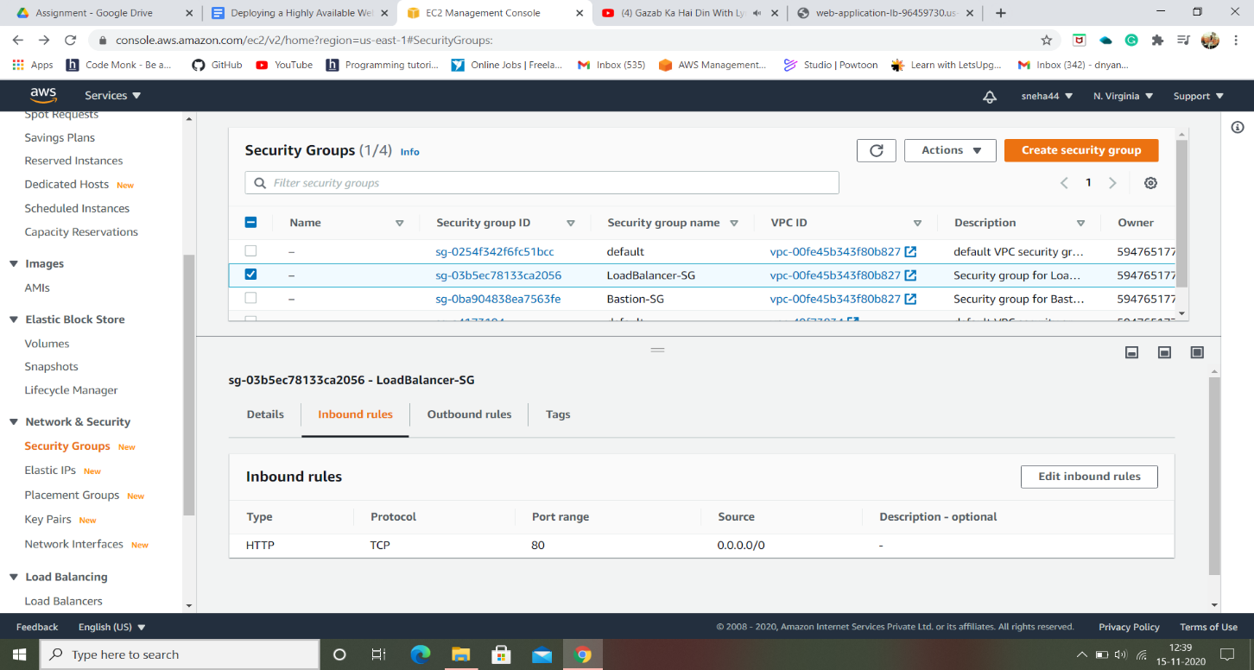

1. Launching two web servers using private subnet:

We have created a private subnet and NAT gateway before in step 2 & 5. The private subnet is attached to a route table to route traffic via NAT gateway to the internet. So as to avail easy access to the internet.

* Launcing a web-server-1 by using two Security Groups such as –“Bastion-SG” and “LoadBalancer-SG”.

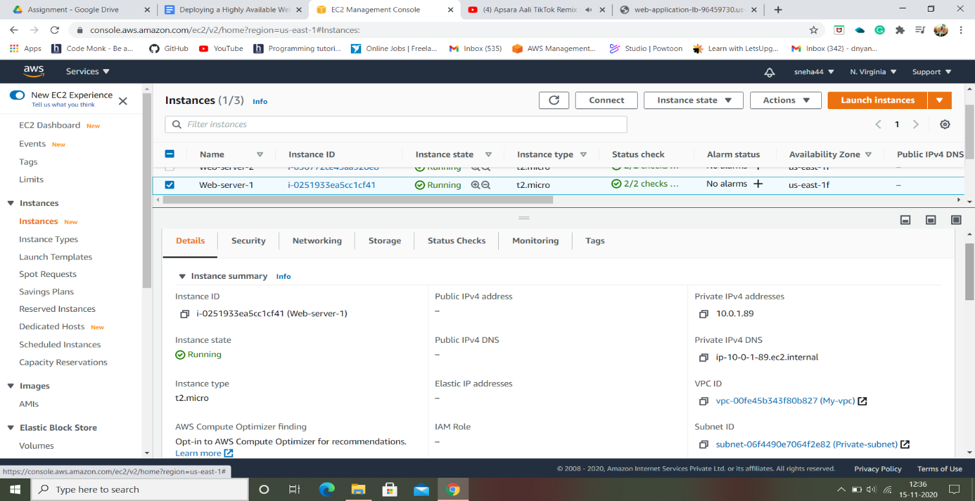

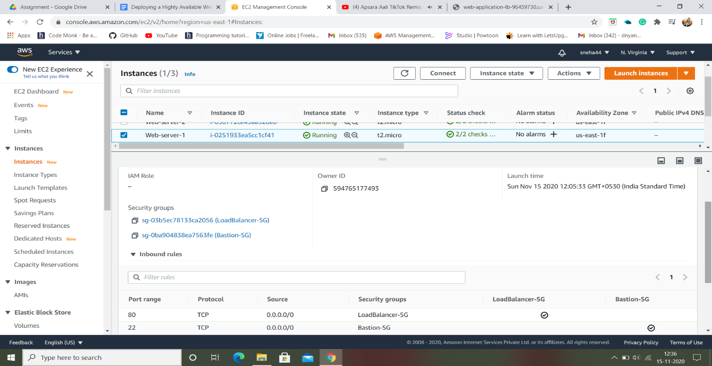

* Same process as web-server-1 to web-server-2:

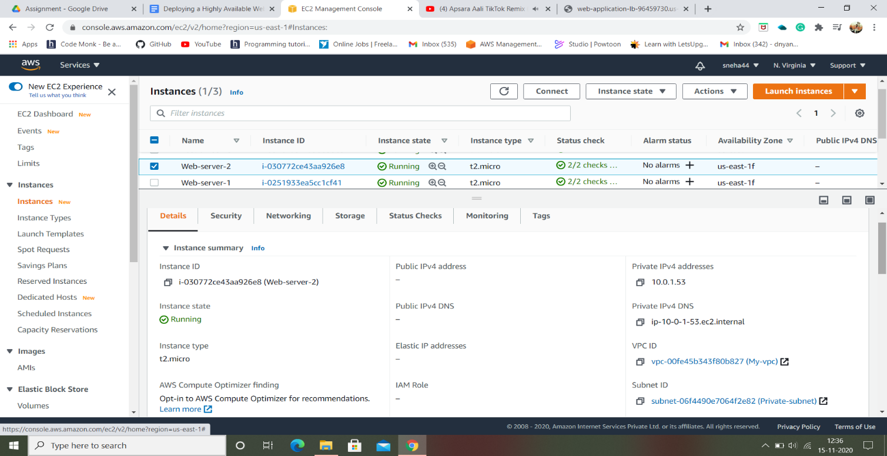

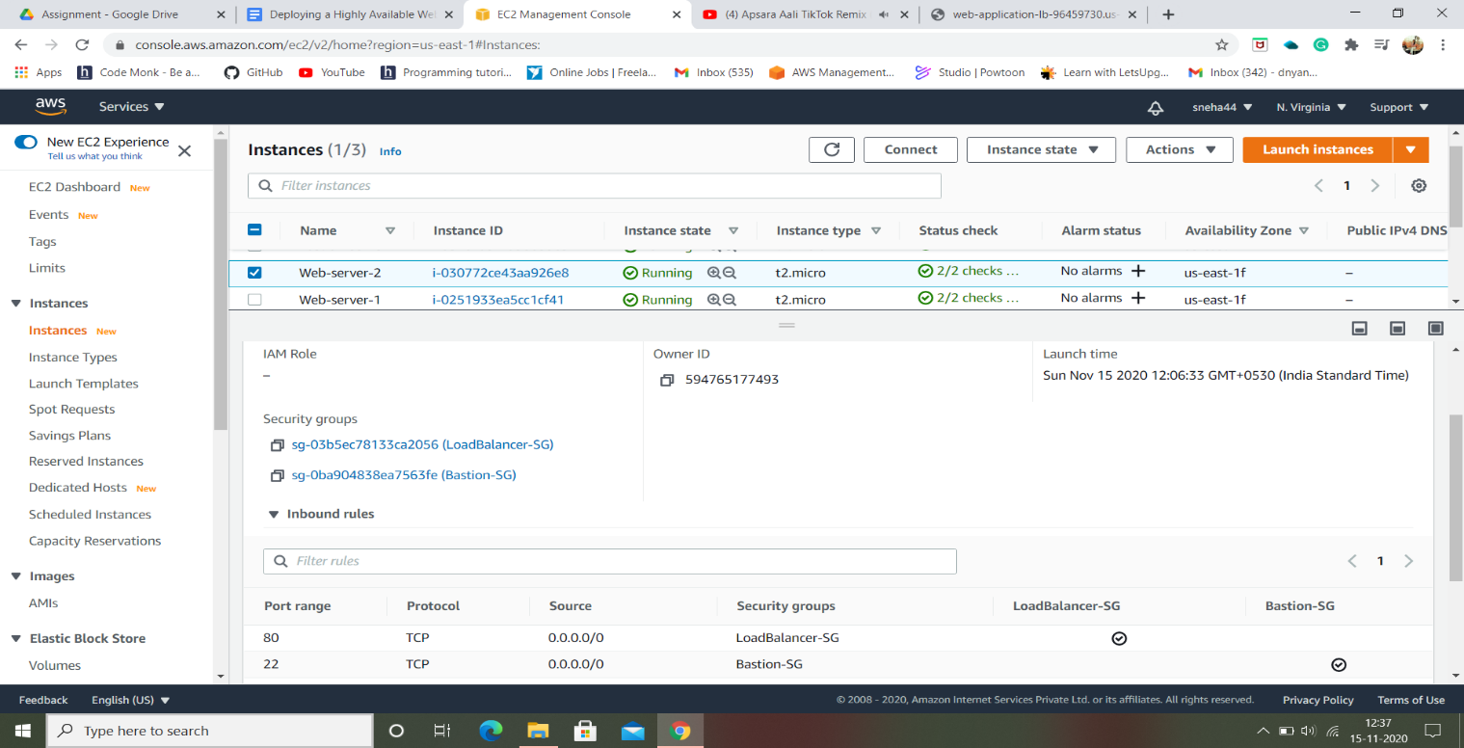

NOTE: Only private IP address will be generated not a public IP address.

1. Creating a load balancer named web-application-LB:

* Selecting all the Availability Zones available with public-subnet as a priority from the vpc we created.

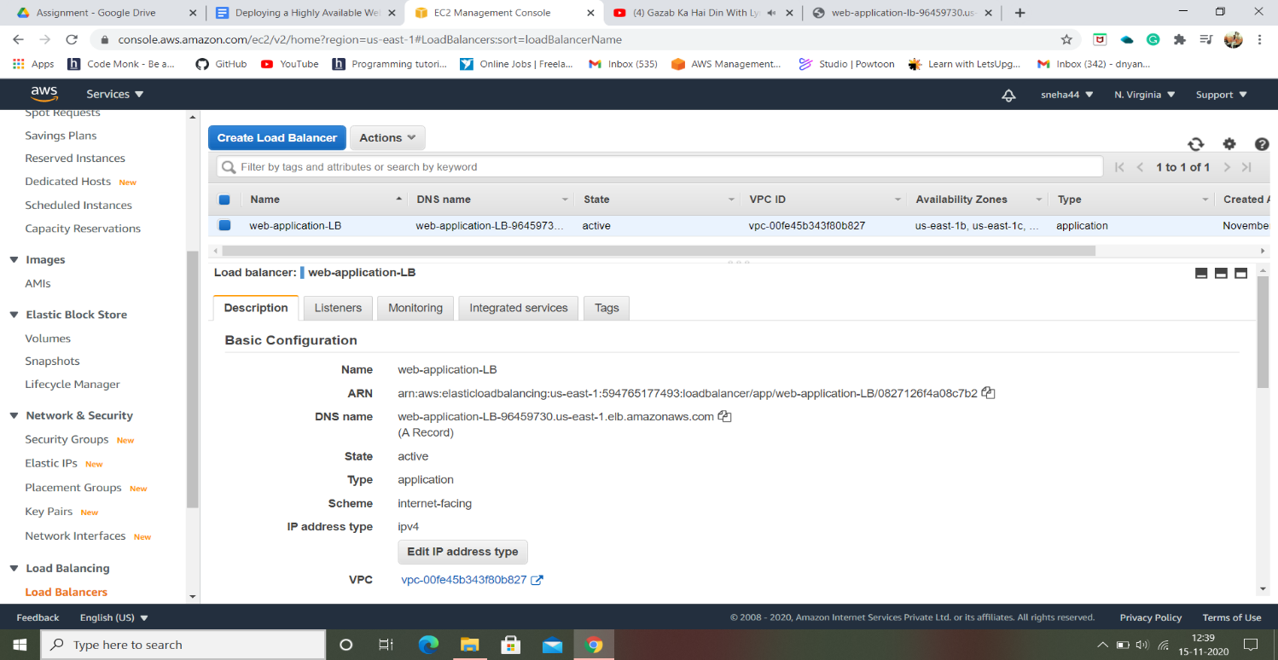

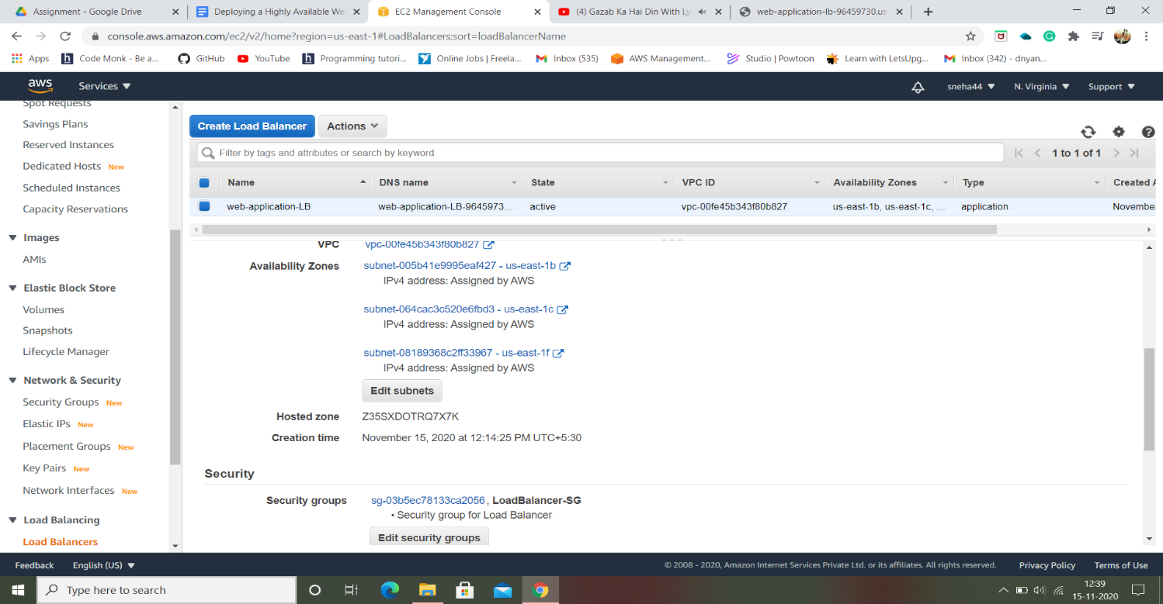

1. Now Connecting a Bastion host server to the internet using a serverkey named “web-serverkey.pem” :
2. To SSH into web servers via Bastion server, we need the web server key that we used to launch the privious web servers (web-serverkey).
3. Open the **web-serverkey** file on your local system and then**copy the text content**.
4. Navigate to the Bastion server and create a file named **web-serverkey.pem** using below command:
5. **vi  web-serverkey.pem**
6. Paste the content and save it by pressing**shift+colon  followed by :wq!**and then enter to save your private key.
7. Make sure you have changed the **permission of the key file to 400**. You can change the permission using below command:
8. **chmod 400 web-serverkey.pem**
9. Now **you can log into the web servers**using the private key copied to the bastion server with the help of below commands.

* **Note:** You **don't have a public IPs** for the web servers since we them in a private**subnet.**
* Syntax**: ssh -i web-serverkey.pem  ec2-user@<**Web-server-1 private IP**>**

1. Now **install the apache service** using the below commands and**create a test index.html file,**which will be **used for a health check.**
2. **Installing Apache:**
   * **sudo su**
   * **yum update -y**
   * yum install httpd -y
   * systemctl start httpd
   * systemctl enable httpd
3. **Creating the example homepage :**
   1. **cd /var/www/html**
   2. **echo “ REQUEST HANDLING BY SERVER 1” > index.html**
4. **Exit from webserver to Bastion server**
   1. To come out of 2nd instance, type **exit** command for coming out of root user, and **exit**command again for coming out of the instance.
5. Repeat steps 7 & 8 for web server 2**with its respective private IP** , making sure to change the content of index.html to “**REQUEST HANDLING BY SERVER 2”**

* To come out of 1st instance, type **exit** command for coming out of root user, and **exit**command again for coming out of the instance.

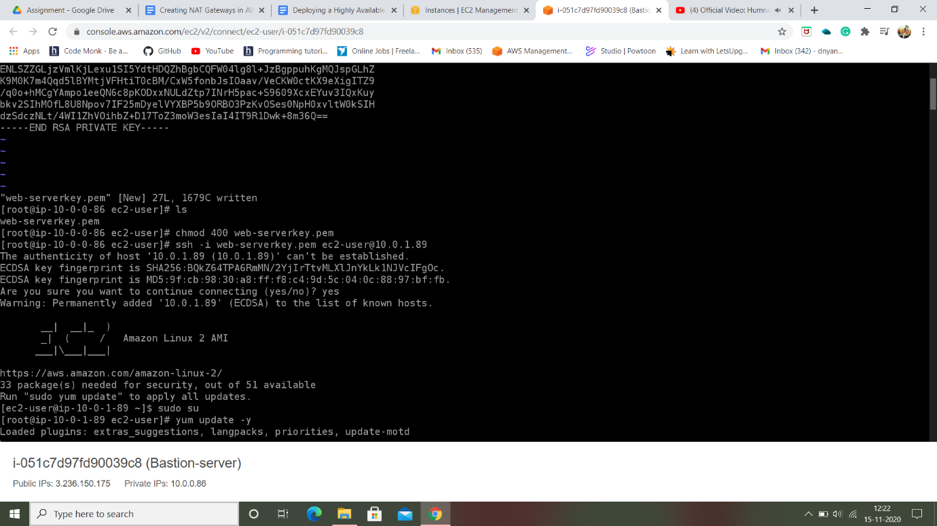

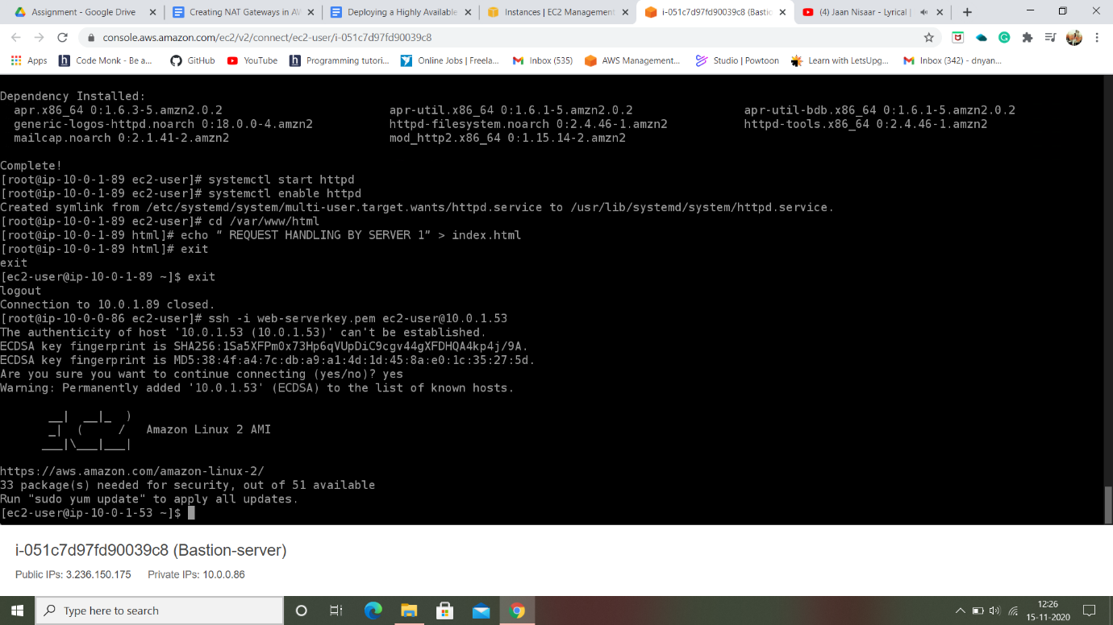

1. Registering the targets “web-server-1 and web-server-2” and check the status if found healthy it means connections are done perfectly else target servers might be stopped or terminated:

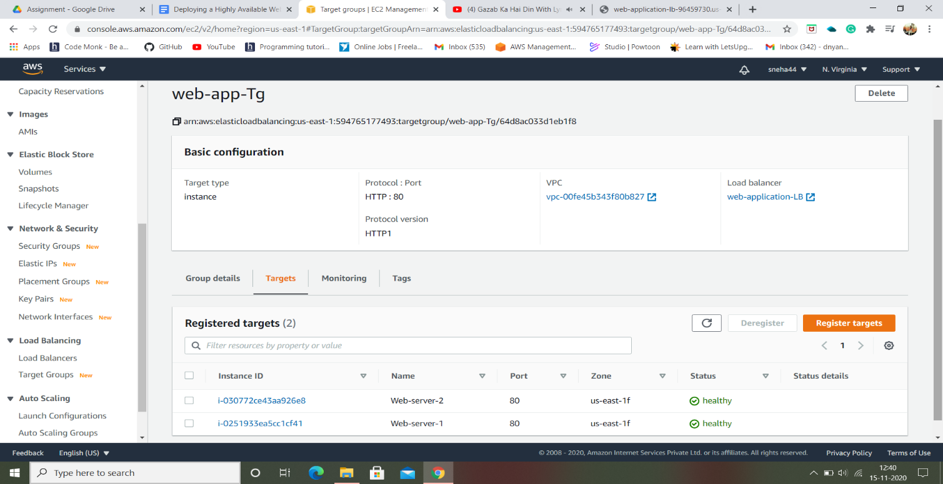

1. Copying the DNS name:

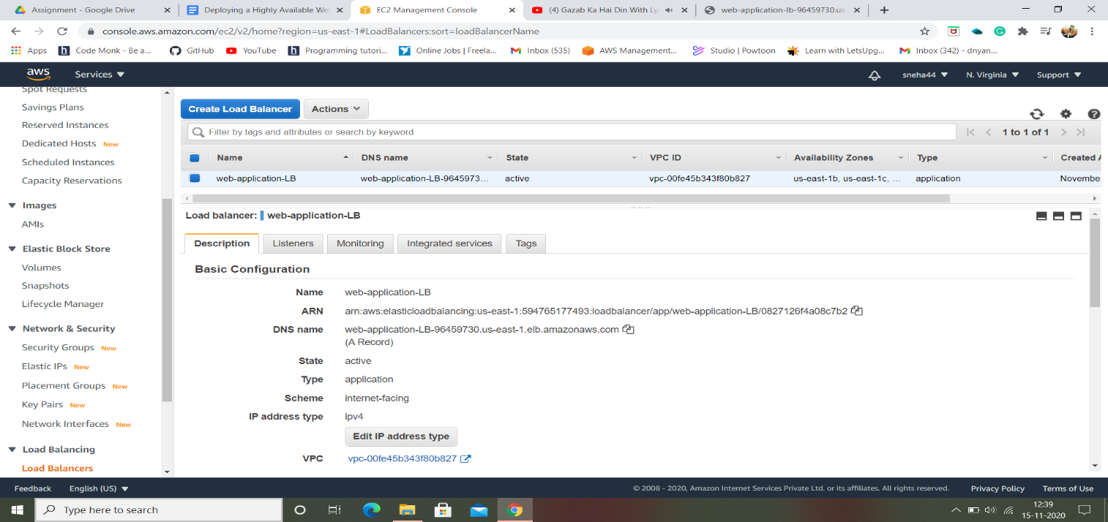

1. Checking whether both servers work accordingly:





1. Test case for high availability:

Here, web-server-2 has been stopped and then the status is checked in target groups which is unused and now when we try to load page error is generated.

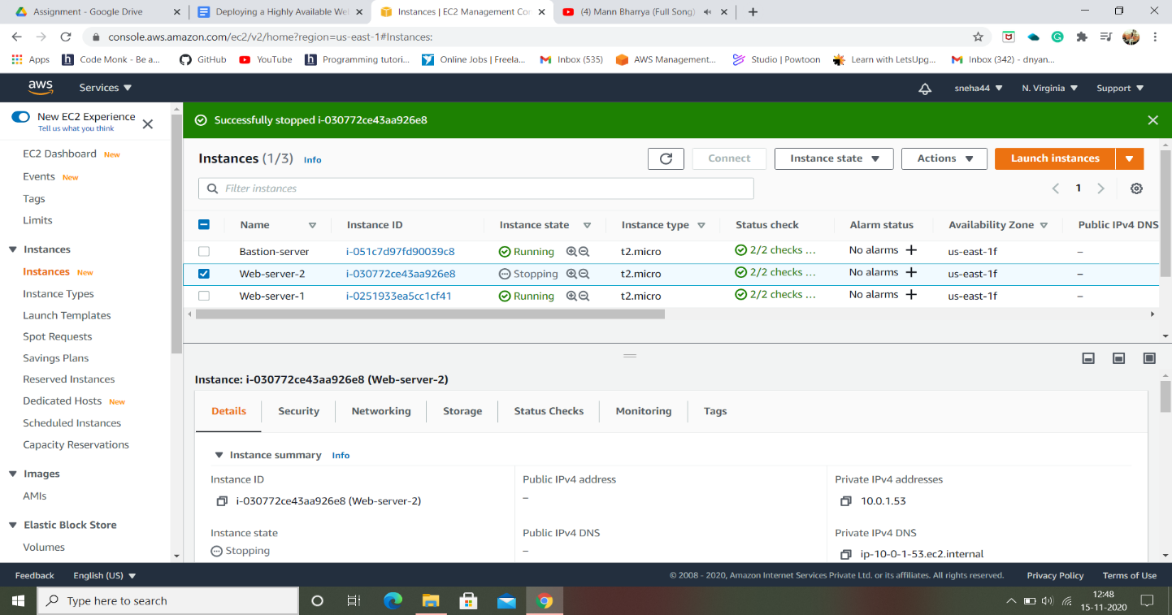

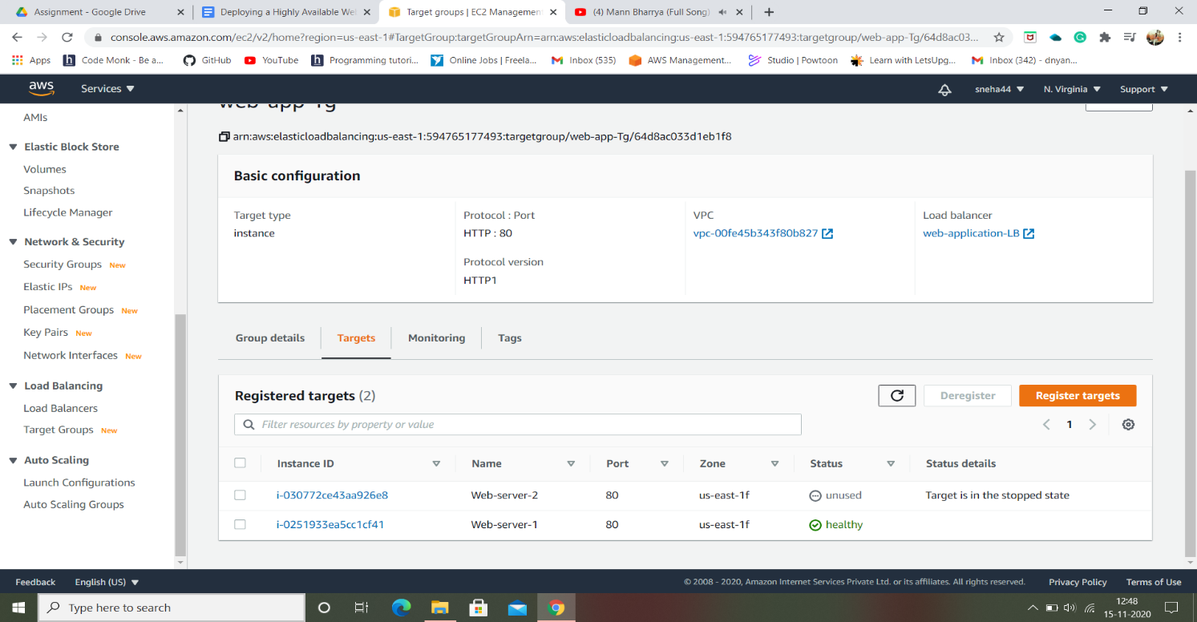

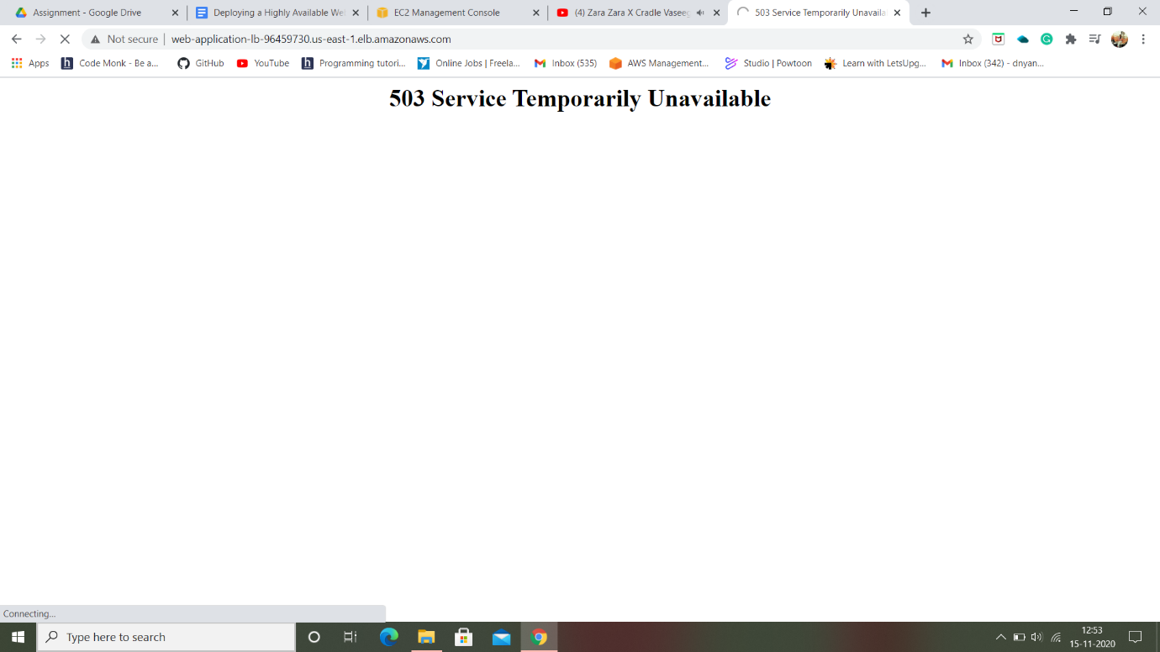

Completion and Conclusion

1. We have launched a Bastion server and two web-servers. We were able to SSH into the servers via Bastion Server successfully.
2. We launched an Application Load Balancer and associated our web servers with the load balancer.
3. We tested the load sharing between web servers.
4. We successfully tested the high availability of the web application by making one of the web servers unhealthy.

Thank You